Linda Mei

Final Project: Piece 3 (Part 1) Octave Tutorial

I followed the Octave documentation and tried the 1.2 simple example section (elementary calculations via. command window, matrix creation/arithmetics, and equations). I followed Mr. STEM EDU TV’s tutorial (<https://www.youtube.com/watch?v=TqwSlEsbObg>) and learned vectors and matrices functions/operations. I also learned to write basic scripts/functions.

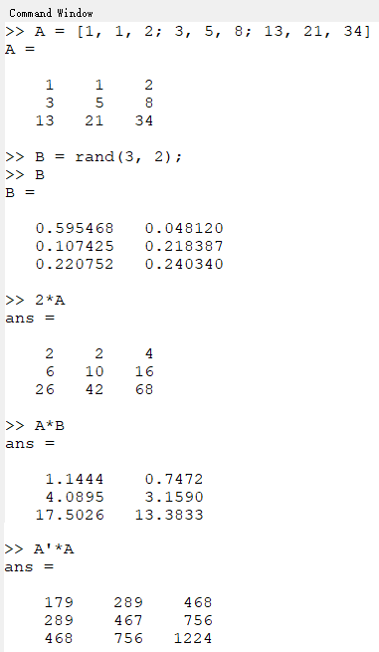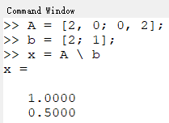

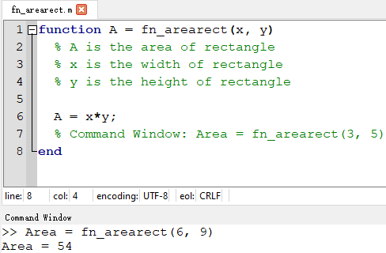

Next, I moved on to the plotting section in the Octave documentation. I plotted points and the cosine function with plot properties. I labeled the graph axes and title and exported it as a pdf.

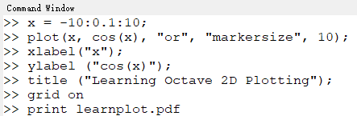

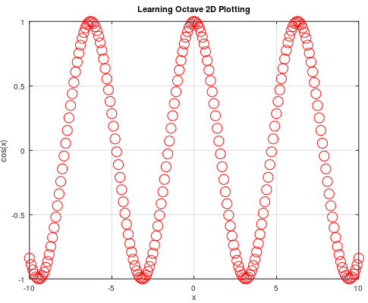

After I learned the basics of plotting, I learned how to load data from a CSV file to plot that data by following Mr. STEM EDU TV’s tutorial (<https://www.youtube.com/watch?v=cLo2UOBU5yY>). When working with CSV files, one needs to be in the same directory as the files’ directories. To read data from a file, one has to use the fopen and fscanf functions. The fopen function reads a file id used in fscanf which also has a specifier depending on what the user wants to do (to read data use “r” and to write data use “w”). The fscanf function reads data based on a specified format and the column and row size. I also learned how to write data into a CSV file.

